Muhammad Shoaib/Saad Salim/Mubeen Ahmed.

Abstract

A Blood Bank Database Program made on C#

Proposal

Blood Bank

Idea: To make a Blood Bank Database Project in C#. Objective of this project is to maintain the Blood Bank System. They have to maintain donor details, Blood component stock details, Screening details, Component preparation details, Blood request, details, Compatibility details, Blood issue details,

Brief Description:  
A database is a collection of persistent data that is used by the application

system of a given enterprise. Traditional databases are organized by fields, records, and files. A field is a single piece of information; a record

is one complete set of fields; and a file is a collection of records. To

access information from a database, we need a database management

system (DBMS). This is a collection of programs that enables the service

providers and clients to enter, organize, and select data in a database.

Presently in Bangladesh 113 Safe blood transfusion centers are providing

safe blood to the clients. The effective management of blood transfusion

program encompasses a good number of areas and one of the areas is

development of data base for the safe blood transfusion centers and also

for the donors. The development of a data base always needed good

documentation. Documentation provides the ability to trace prospectively

and retrospectively all steps in all procedures, dating from collection of the

blood to monitoring techniques, component preparation, laboratory testing,

issue and transfusion of blood. An effective record system helps to judge

the performance of the blood transfusion service traces any donated unit

of blood from its source to the final fate and also helps in legal or

investigational purposes. The safe blood transfusion authority in

Bangladesh already developed some document with an aim to maintain

records of different activities which are not sufficient for meeting the future

challenge for upholding quality and accessibility to the services.

Technology Used: C#, Oracle Database.

Application Process Flow of Blood Bank:

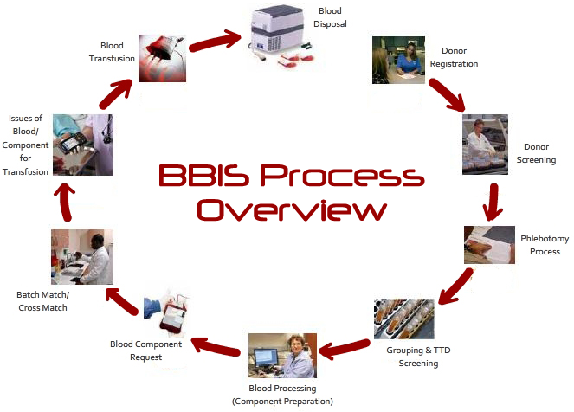

ER-Diagram of Blood Bank:

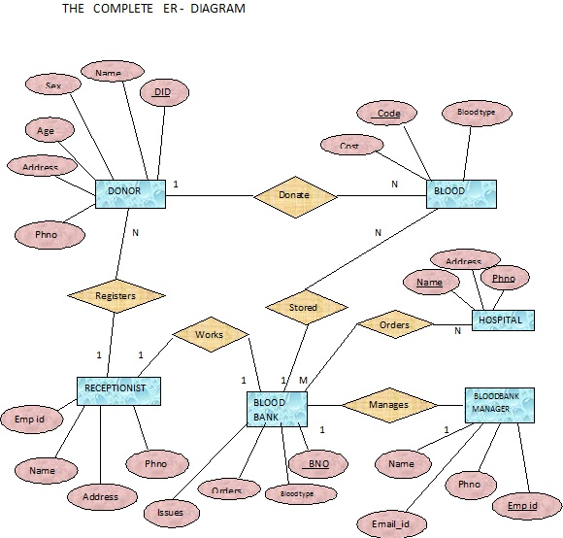

Conclusion: This was an effort to create a simple blood bank database project which may be useful in a blood bank to insert, store, handle and retrieve information about store blood, blood bank staff, blood donors and blood receptionists. I have you will like this project.